TECHNICAL PROJECT REPORT

# Title of Invention / Project: THE BUTTON GAME

# Team Members / Inventors:

|  |  |  |  |  |  |
| --- | --- | --- | --- | --- | --- |
| **S. No.** | **Name** | **Department** | **Designation** | **Mobile** | **E-Mail** |
|  |  |  |  |  |  |
| 1. | Yash Agarwal | AI&ML1 | Student | 73798833733 | agarwalyash1410@gmail.com |
| 2. | Gursimarpal Singh | AI&ML1 | Student | 7340840032 | gsimarpal7@gmail.com |
| 3. | Amit Yadav | AI&ML1 | Student | 8874423638 | sy4306122@gmail.com |
| 5. | Khushal Thakur | ECE | Mentor | 9646030764 | khushal.thakur@cumail.in |
| 6. | Anshul Sharma | ECE | Mentor | 9478697475 | anshulsharma.ece@cumail.in |
| 7. | Kiran Jot Singh | ECE | Mentor | 9463909689 | kiranjotsingh.ece@cumal.in |
| 8. | Divneet Singh Kapoor | ECE | Mentor | 9878422653 | divneet.ece@cumail.in |

Section – 1 (IPR Related)

# Brief Abstract (500 words):

* Problem your project is solving
* How are you solving that (solution)?
* Additional modifications that can cater to improved solution

It is a simple button game which is played by two players at a time. The concept is very simple, whosoever presses the button 21 times first will win the game. It is an interesting game which is correlated to arm wrestling. Just like whosoever applies more pressure wins the game in this also whosoever rapidly clicks 21 time will win the game.

We have connected two arduino with two buttons which records the number of clicks by each player. The main arduino is connected with lcd. The arduino which has first 21 clicks will send signal to the main arduino which orders to the lcd to display the winner on the screen. To make it more interesting we have connected to leds to each arduino. Like in every click one led glows and every fifth click all leds off and one main led glows and after 21 clicks one main led start glowing and other leds start blinking. This seeks the attention of the player to play it and concept has been made more interesting by this led concept.

Yes there can still many modifications which can be done like the design of the game is too obsolete. It can be modified. Despite the design led concept has been used to make the game more attracting. This concept can also be replace or can be modified by a better one to make it more attracting.

# Existing state-of-the-art and Drawbacks in existing state-of-the-art

(*Brief background of the existing knowledge*)

|  |  |  |
| --- | --- | --- |
| **S. No.** | **Existing state of art** | **Drawbacks in existing state of art** |
| 1 |  |  |
| 2 |  |  |

# Novel/Additional modifications that you can propose to improve upon drawbacks

*(List down the features)*

* Feature 1
* Feature 2

# Advantages

(*List down the advantages, if each feature is incorporated)*

* It is a simple game which tests the speed of an individual.
* Programming concept has touched another level.

# Block Diagram

(*Functional diagram depicting the flow of information in your system. Do not define exact components, only use generic terms. Must include modifications as well.)*

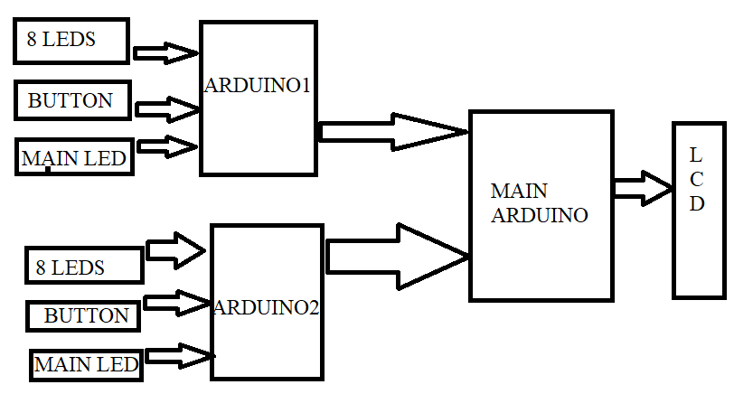

Section – 2 (Real Project)

# Materials

(*List down the Components, Equipment, etc. actually used in the project*)

* LEDS
* BUTTON
* WIRES
* BATTERIES
* PCB BOARD
* ARDUINO
* BATTERY CAP
* PLASTIC BOX
* LCD DISPLAY
* SWITCH

# Circuit Diagram

(*Fully functional circuit diagram with exact connections. Can use Fritzing/Proteus*)

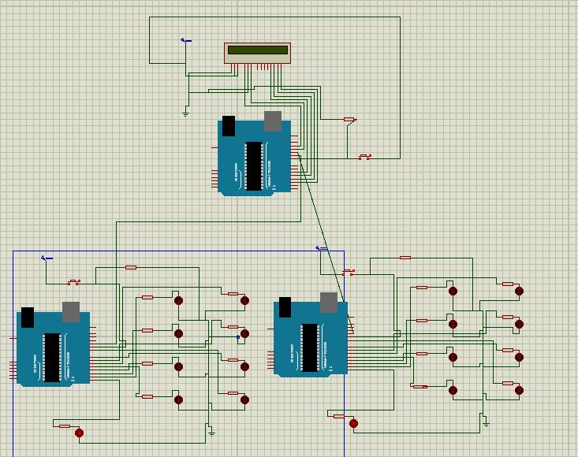

# Steps of Circuit Completion

(*Bifurcate the circuit completion in steps, specify with photographs, leading to final project*)

* CONNECTED 8 LEDS TO ONE ARDUINO
* CONNECTED A SWITCH AND THE MAIN LED WITH IT
* CONNECTED A BATTERY WITH IT
* SIMILARLY DESIGNED THE SECOND ARDUINO
* THE CONNECTED THE MAIN ARDUINO WITH A LCD DISPLAY
* THE CONNECTED BOTH THE SECONDARY ARDUINO WITH THE MAIN ARDUINO WITH DIFFERSENT PINS.

# Program Code

https://github.com/AMITYADAV88744/PROJECT